**Government Polytechnic,Pune**

(An Autonomous Institute of Government of Maharashtra)



Microproject report on   
**E-Waste Management of Pune City**

Submitted By

|  |  |  |
| --- | --- | --- |
| SR NO. | NAME | ENROLLMENT NUMBER |
| 1 | WAYAL SHRAWAN ARUN | 2206181 |
| 2 | DALVI SHRAVANI MAHENDRA | 2206182 |
| 4 | SHRINIWAR AJAY GANESH | 2206183 |
| 5 | SOLANKAR CHAITANYA SATISH | 2206184 |

Under the guidance of

# Mrs. K.V.Mankar

**(Academic Year:2022-23)**

**Government Polytechnic,Pune**

(An Autonomous Institute of Government of Maharashtra)

**Department of Computer Engineering**



# CERTIFICATE

This is to certify that Mr. Shrawan Arun Wayal ,Mr. Ajay Ganesh Shriniwar , Miss. Shravani Mahendra Dalvi , Mr.Chaitanya Satish Solankar with Enrollment No.2206181 , 2206182 , 2206183, 2206184 of Second Semester of Diploma in Computer Engineering of Institute, **Government Polytechnic, Pune** has successfully completed the**Microproject** Titled ‘E waste management in pune city**’**in the Course as part of his curriculum in academic year 2022-23.

(Project Guide) (Head Of Department) (Principal)

Mrs. K.V.Mankar Mrs.M.U.Kokate Dr.V.S.Bandal

**ABSTRACT**

Pune is one of the major hubs of E-waste generation in India. According to several studies Conducted in India, Pune is a major repository of WEEE. The Mumbai-Pune industrial belt is one of the electronic goods manufacturing hubs of the country. This study focuses on e-waste generated in Pune and Pimpri Chinchwad, understanding material flow and trade chain in the two cities, processes of recycling and disposal covering the informal sector, environmental impact of e-waste recycling and assesses the capacities of existing stakeholders.

This study tells the story of the journey of E-waste and its movement from the point of Generation through collection, trading, intermediate processing, forwarding and final disposal in the city of Pune. The study is exploratory rather than exhaustive in scope and was carried out 6 over a brief period of two months. The findings are indicative rather than conclusive. The study draws upon secondary sources of information including research studies and reports as well as primary sources that were willing to volunteer information.

**ACKNOWLEDGEMENT**I would like to express our sincere gratitude to my Microproject Guide **Mrs.K.V.Mankar** and Head of Department **Prof.Mrs. M.U.Kokate**, for lending there precious time in spite of there busy schedule. I would like to thank to give us her valuable advice, and guidance throughout the project. She is clear with the Project objective and pointed out the requirement, and put me back on track. It is my pleasure to work under her guidance. We find it hard to imagine that anyone else could be more patient, sincere and a better advisor than she.

I would also like to give thanks to **Prof. Mrs. M.U.Kokate,** HOD for continuous support, guidance and inspiration in all the phases of our project work.

We sincerely thank the staff of the **Computer Engineering Department** for constant encouragement and valuable advice. We would like to thank our Principal **Prof. Dr.V.S.Bandal**for providing all necessary facilities to complete our Microproject work.

|  |  |  |  |
| --- | --- | --- | --- |
| SR.NO | Name of Student | Duration of working | Work done |
| 1. | Shrawan Arun Wayal |  |  |
| 2. | Shravani Mahendra Dalvi |  |  |
| 3. | Ajay Ganesh Shriniwar |  |  |
| 4. | .Chaitanya Satish Solankar |  |  |

**INDEX**

|  |  |  |
| --- | --- | --- |
| **Sr.No.** | **Name of the Chapter** | **Page No** |
| **1** | **Introduction** | **1** |
| **2** | **What is e-waste ?** | **2** |
| **3** | **Types of e-waste** | **3-5** |
| **4** | **E-waste current status in pune** | **6-8** |
| **5** | **Major concerns related to E-waste** | **9** |
| **6** | **Causes of E-waste in pune city** | **10** |
| **7** | **E-waste projection in pune** |  |
| **8** | **Current E-waste management in pune** |  |
| **9** | **Current recycling process in pune** |  |
| **10** | **Major NGO’s and private enterprises** |  |
| **11** | **Conclusion and References** |  |

**Introduction**

**Pune is a rapidly developing city in India that is home to a large and growing population. The city has seen a significant increase in the production and consumption of electronic devices in recent years, which has led to a corresponding increase in e-waste generation. The improper disposal of e-waste in Pune has become a significant environmental and health concern, requiring urgent attention and action.**

**This report focuses specifically on the issue of e-waste in Pune, India. It will provide an overview of the current state of e-waste management in Pune, including the environmental and health impacts of improper disposal and current management practices. It will also explore the challenges faced by various stakeholders in managing e-waste in the city and potential solutions to address the issue.**

**The report will draw on data and information from various sources, including government reports, academic research, and industry sources. It will provide insights into the scale and nature of the e-waste problem in Pune, and the efforts being made to manage and mitigate its impacts. Ultimately, the report aims to raise awareness about the issue of e-waste in Pune and stimulate discussion and action to improve e-waste management practices in the city.**

**The improper disposal of e-waste can lead to environmental pollution, including the release of toxic chemicals and heavy metals into the soil, air, and water. Additionally, e-waste can pose a health hazard to humans who are exposed to it. Many electronic devices contain hazardous materials such as lead, mercury, cadmium, and brominated flame retardants, which can cause damage to the nervous system, kidneys, and reproductive system.**

**The management of e-waste is a significant challenge for governments, environmental organizations, and the electronics industry. To address this issue, there have been several initiatives aimed at improving the collection, disposal, and recycling of electronic waste. These initiatives include the implementation of e-waste management policies, the development of e-waste collection and recycling programs, and the promotion of sustainable manufacturing practices.**

**WHAT IS E-WASTE ?**

Electronic waste or e-waste describes discarded electrical or electronic devices. Used electronics which are destined for refurbishment, reuse, resale, salvage recycling through material recovery, or disposal are also considered e-waste. Informal processing of e-waste in developing countries can lead to adverse human health effects and environmental pollution.

E-waste is any electrical or electronic equipment that’s been discarded. This includes working and broken items that are thrown in the garbage or donated to a charity reseller like Goodwill. Often, if the item goes unsold in the store, it will be thrown away. E-waste is particularly dangerous due to toxic chemicals that naturally leach from the metals inside when buried.

E-waste contains a variety of materials, some of which are hazardous to human health and the environment. These materials include heavy metals such as lead, mercury, and cadmium, as well as flame retardants, polychlorinated biphenyls (PCBs), and other toxic chemicals. When improperly disposed of, these materials can leach into soil and water, causing environmental pollution and posing a risk to human health.

* **TYPES OF E-WASTE**

1. **Computers and Laptops: This includes desktops, laptops, tablets, and related peripherals such as keyboards, mice, printers, and scanners.**
2. **Televisions and Monitors: This includes CRT, LCD, LED, and plasma televisions and monitors.**
3. **Mobile Phones and Accessories: This includes smartphones, basic mobile phones, chargers, and earphones.**
4. **Audio and Video Equipment: This includes DVD players, audio players, and home theater systems.**
5. **Cameras and Camcorders: This includes digital cameras, video cameras, and related accessories.**
6. **Appliances: This includes refrigerators, washing machines, air conditioners, and other household appliances.**
7. **Batteries: This includes batteries used in various electronic devices and equipment.**
8. **Electronic Toys and Games: This includes gaming consoles, electronic toys, and other entertainment devices.**

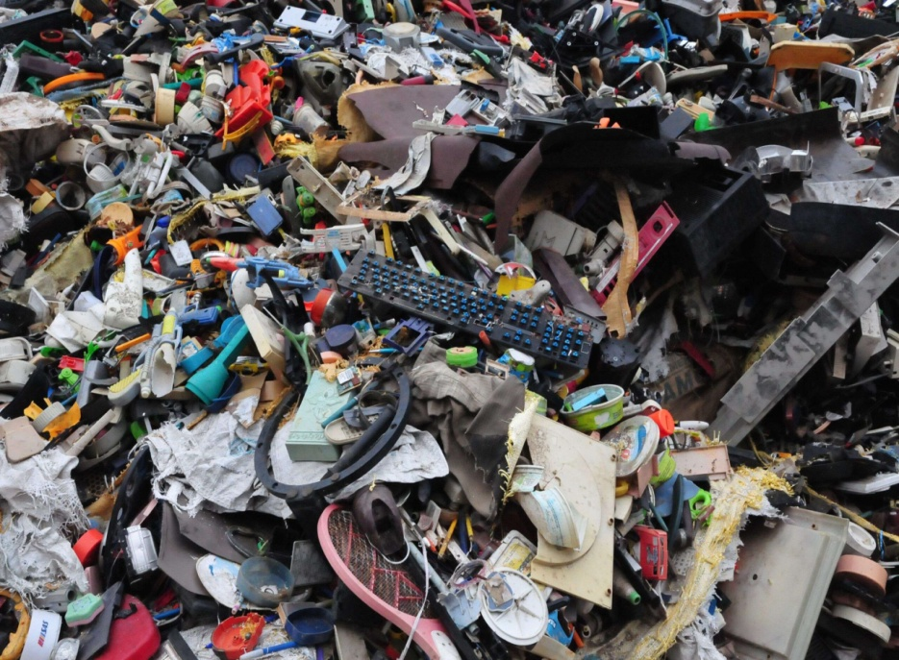

**e-waste production in pune**

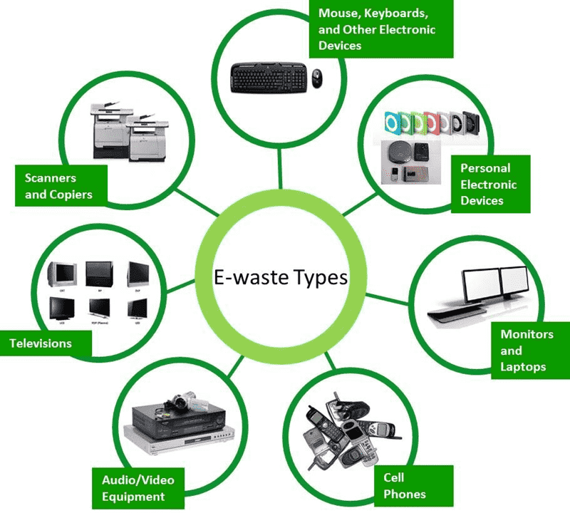

* 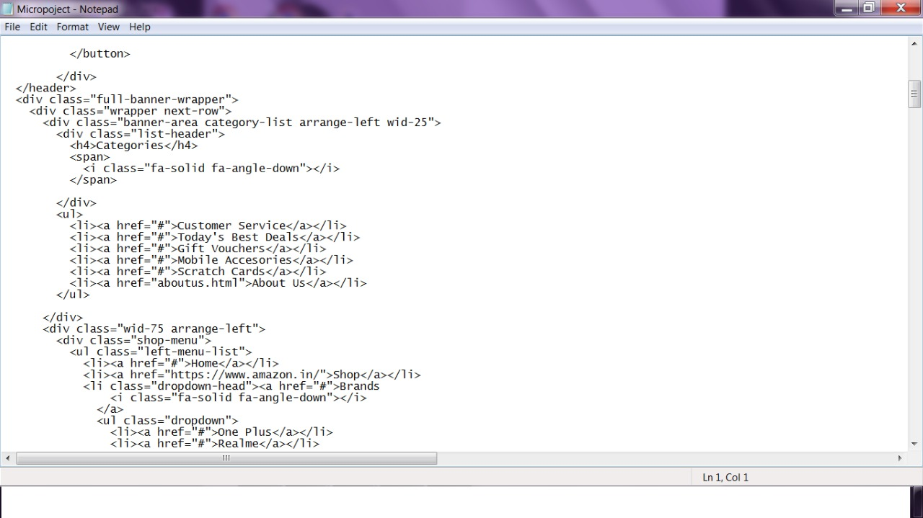 **E-WASTE - CURRENT STATUS IN PUNE AND PIMPRI CHINCHWAD**

There are two aspects which have to be looked at when referring to E waste in the Pune region. The first is the extent of use of goods that would potentially generate E waste. The second is whether there is significant large scale E- waste recycling in Pune that creates a demand for imports of E waste from other towns and cities as well. In the first case, appropriate collection and dismantling and transport/forwarding is the critical factor, while in the second the environmental implications and consequences of the recycling processes within the city, also need to be addressed.

The IT directory brought out by the Mahratta Chamber of Commerce Industry and Agriculture (MCCIA) lists 1000 IT and ITES companies and IT educational establishments in Pune alone. Contrary to the traditional image of Pune, the city now boasts of a number of famous educational institutes in India like the National Defence Academy, IUCAA, NCL, FTII, and is a host to leading software companies like Infosys, IBM, Wipro, Tata Technologies and Software Technology Park of India (STPI). Due to this, an increasing portion of Pune‟s population consists of students, IT professionals and BPO workers.

On the one hand, this contributes to creating a vibrant commercial and cultural environment in Pune. But it also means that usage of electrical and electronic goods is high in the city making it an important city in terms of e-waste generation in India. A 2007 report by Maharashtra Pollution Control Board on e-waste in Mumbai and Pune region states that along with Mumbai, Pune is among the top ten cities that generate the maximum e-waste in the country. As such it is difficult to get precise estimates of the amount of e-waste generated in Pune. This is because most of the waste generated does not enter the waste stream at all. Further, there are no studies yet to assess the rate of obsolescence of electrical and electronic goods which can be used along with data on the supply of such goods to estimate the quantity of ewaste generated in the city.

However, a study done by the Maharashtra Pollution Control Board in 2007 did draw up an estimate according to which the Pune Municipal Corporation and Pimpri Chinchwad Municipal Corporation area together accounted for over 3616.58 tonnes of E-waste annually. However, the current study shall not attempt to work with figures of e-waste and the amounts going into different streams. Rather it shall try to understand the people and the processes which are involved in e-waste collection and handling, the strengths of the current system as well as its weaknesses. This would assist us in identifying areas in which interventions would help reduce the hazards posed by e-waste whilst increasing its contribution to society in terms of better livelihoods and lowering the demand for primary resources.

Pune is a bustling city in the western Indian state of Maharashtra. Also called “Queen of the Deccan,” it is the cultural and educational capital of Maharashtra. The Pune Metropolitan Region (PMR), initially defined in 1967, has grown to 7,256 km2 made up of the ten talukas of the Pune district (1). The twin cities of Pune and Pimpri-Chinchwad along with the three cantonment areas of Pune, Khadki and Dehu Road form the urban core of the PMR, which also includes seven municipal councils in 842 villages.

Pune is also known as the "Oxford of the East" due to the presence of several well-known educational institutions, management schools, training centers, etc., that attract students and professionals from India and overseas. A sprawling complex of industrial suburbs has developed around the city. Pune is considered to be the eighth largest metropolitan economy of India with key sectors including IT, manufacturing and education. It houses some of the internationally popular automobile companies like Mahindra & Mahindra, General Motors, Volkswagen, Renault and others. Pune Municipal Corporation (PMC) is the civic body responsible for local governance. It is in charge of the civic needs and infrastructure of the metropolis, which is spread over an area of 331.26 sq. km. and has 3.8 million residents (2). This population is growing rapidly owing to Pune’s well-established industrial and educational set-up, and the booming IT sector in the city.

|  |  |
| --- | --- |
| PUNE | CITY |
| STATE | **MAHARASHTRA** |
| DISTRICT | **PUNE** |
| LATITUDE | 18.5204° N |
| LONGITUDE | 73.8567° E |
| POPULATION | **3.8 MILLION** |
| PINCODE | 411001-411062 |

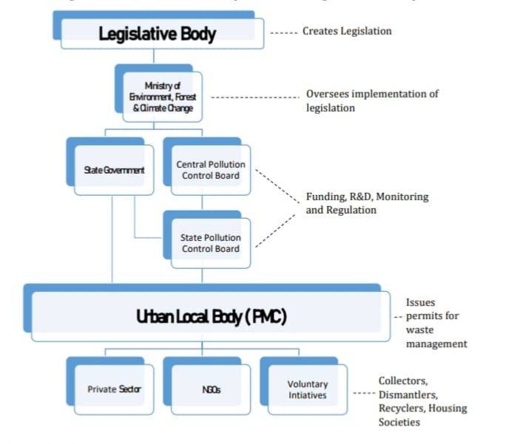

MAJOR CONCERNS RELATED TO E-WASTE

The villagers living around the Uruli landfill in Pune agitated for years, and even moved theCourts demanding that they did not want the stinking, rotting garbage of Pune to be dumped in their backyards. Their struggles have been covered extensively by the local press. E-waste on the other hand, neither rots nor stinks. Rather it comprises stately-looking products such as computers, refrigerators, mobile phones, televisions and other gadgets. They are costly, coveted items that apparently do not create as much nuisance as the fruit and vegetable markets with their odorous rotting wastes. The glitter gets considerably tarnished when these same symbols of technological progress become unusable relics and have to be taken apart into their constituent components in the scrap recovery markets.The processes of collecting and dismantling of items that can be classified as e waste, as also the extraction of trace metals and other materials, are primarily carried out in the informal sector. Poor regulation, low technology, manual processes, relatively less skilled labour, absence of safety measures for workers and low operating costs are some of the features of the informal waste recycling sector (Chikarmane et al. 2001).Hazardous elements in Ewaste include lead, cadmium and mercury which are released during the process of dismantling. Further, the processes of recycling and extraction are often highly hazardous in nature. For instance, the extraction of gold from printed circuit boards is done by using mercury and acid baths. However, no precautions are taken for the safety of those engaged in giving the acid baths and they come into regular contact with cyanides, nitric acid fumes and mercury. Further, the highly toxic by- products of the processes (such as the left over acids and mercury) are released into our land and water bodies without any measures to safeguard against their harmful effect on the health of the environment. Greenpeace International in its study of E waste recycling in Delhi, India and China found that “all stages in the processing of electrical and electronic wastes have the potential to release substantial quantities of toxic heavy metals and organic compounds to the workplace environment and, at least to the extent studied, also to surrounding soils and water courses. The processes listed were component separation and solder recovery; mechanical shredding; acid processing and leaching. Among the toxic heavy metals most commonly found in elevated levels in wastes from the industry, as well as in indoor dusts and river sediments, were those known to have extensive use in the electronics sector, i.e. lead, tin, copper, cadmium and antimony” (Brigden, 2005).

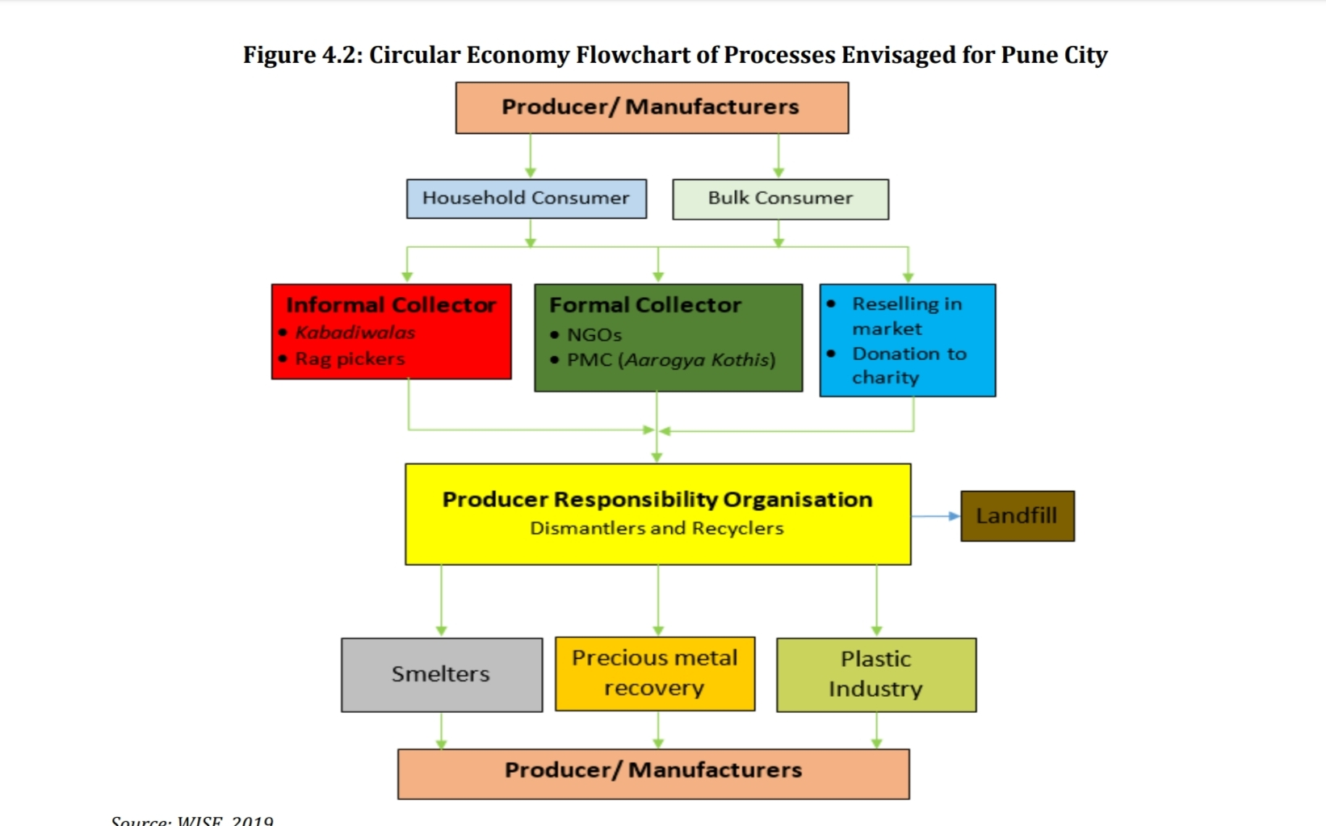

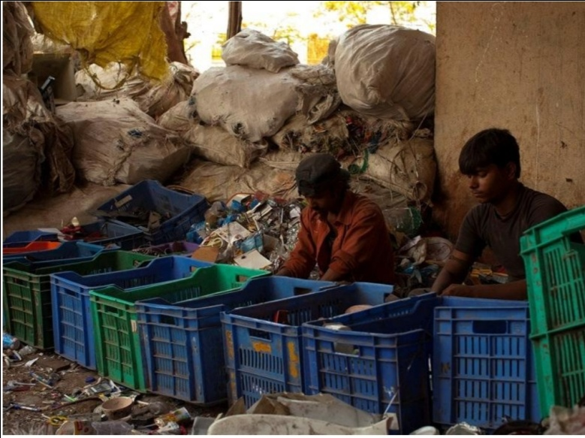

**Workers manully sorting e waste components**

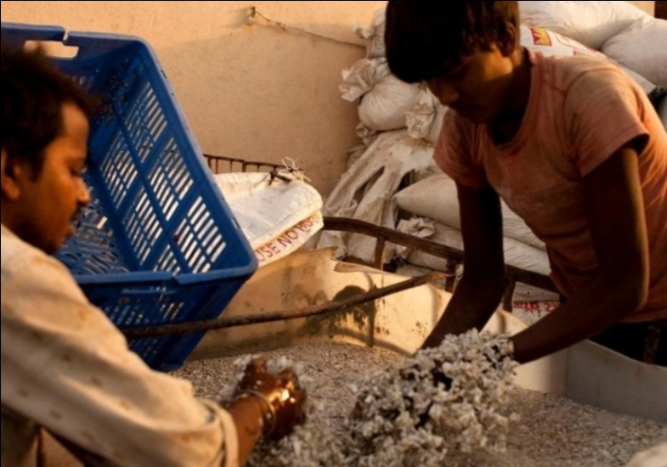

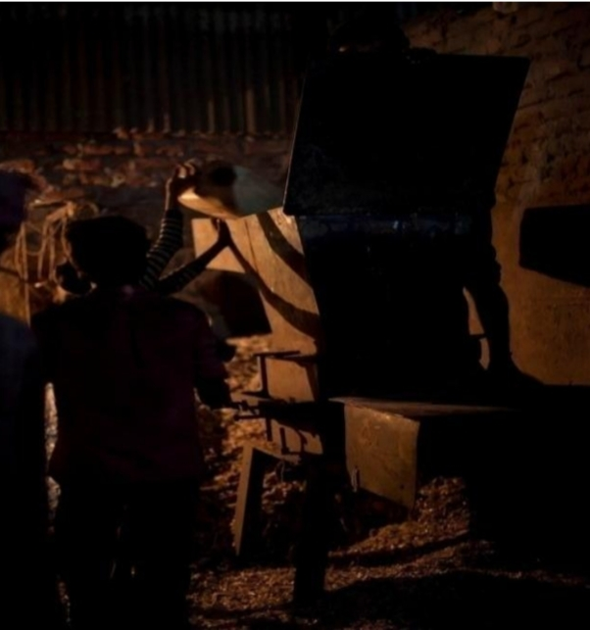 **Manually washing e waste plastic**

**Causes of E-waste in pune city**

1. Rapid technological advancements: With the rapid advancements in technology, electronic devices are becoming obsolete faster than ever. People are discarding old devices to upgrade to newer, faster, and more advanced ones.
2. Increasing population: Pune city's population is rapidly increasing, leading to more demand for electronic devices. As the population grows, so does the amount of e-waste generated.
3. Lack of proper disposal facilities: There is a lack of proper disposal facilities for e-waste in Pune city, and most people do not know how to dispose of their old electronics properly. As a result, they end up disposing of them in landfills or burning them, which leads to environmental pollution.
4. Lack of awareness: There is a lack of awareness among people about the harmful effects of e-waste on the environment and human health. Many people do not realize that e-waste contains hazardous substances like lead, mercury, and cadmium, which can leach into the soil and water and cause serious health problems.
5. Illegal e-waste dumping: There have been instances of illegal e-waste dumping in Pune city, where electronic devices are dumped in open spaces or water bodies, leading to environmental degradation.
6. Overall, e-waste generation in Pune city is a complex issue that requires a multi-pronged approach involving awareness campaigns, proper disposal facilities, and stricter regulations on e-waste disposal.

**E-waste Projection in Pune**

1. **Cell Phone**

The data obtained from Cellular Operators Association of India (COAI), Telephone Regulatory Authority of India (TRAI) and Census of India for the time dependent increase of installed base and yearly additions of cell phone in Puneis calculated.The number of cellular phones introduced into the E-waste market from the installed base in the region was further augmented by considering the external factors. It includes the number of cellular phones brought into Pune market from other sources. The average weight of cellular phones has been taken as 102.86 gm. Based on the secondary data review for cellular phones. considering obsolesce of 2 years the amount of E-waste in Pune by year 2015 is estimated and projected to be 44.49 tons.

**b. Personal computer**

The data obtained from Census of India and MAIT for the time dependent increase of installed hase and yearly additions of personal computer in Pune is calculated. The average weight of PC has been taken as 27.2 kg. For Personal computer based on the secondary data review, considering obsolesce of 5 years the amount of E-waste generation in Pune by year 2015 is estimated and projected to be 1183 tons.

1. **Refrigerator**

The data obtained from Census of India and TeleVision Vecpaar Journal, Indu from 1987, for the time dependentincrease of installed base and yearly additions of refrigerator in Pune is calculated. The average weight of refrigeratorhas been taken as 48 kg. For refrigerator based on the secondary data review, considering obsolesce of 15 years theamount of E-waste in Pune city by year 2015 is estimated and projected to he 1949.5 tons.

**d. Television**

The data obtained from Census of India and TeleVision Veepaar Journal, India from 1987, for the time dependent increase of installed base and yearly additions of television in Pune is calculated. The average weight of IV has been taken as 36.5 kg. For refrigerator based on the secondary data review, considering obsolesce of 15 years the amount of e-waste in Pune by year 2015 is estimated and projected to be 1395.5 tons

**CURRENT E-WASTE MANAGEMENT SYSTEM IN PUNE CITY**

In accordance to E-Waste Management Rules, 2016, the Central Pollution Control Board (CPCB) prepared guidelines on implementation of e-waste rules and handed it over for implementation to the State Pollution Control Board, the Maharashtra Pollution Control Board (MPCB). MPCB is the regulatory body for the state of Maharashtra and responsible for monitoring and reviewing e-waste handling and management as per the rules. It is also responsible for granting and renewing authorization, monitoring the compliance of the various provisions and conditions of authorization, forwarding applications for import as per rules and reviewing matters pertaining to identification and notification of disposal sites (4). Pune Municipal Corporation (PMC) is the urban local body responsible for end-to-end solid waste management in the city. PMC currently has a small e-waste cell. But due to the lack of suitable guidelines and regulations, the role of the cell is not defined and there is no dedicated manpower to carry out the responsibilities appropriately. PMC has designated 177 temporary collection centers to collect e-waste across Pune city. Due to lack of awareness amongst citizens, very little e-waste is collected which is not monitored appropriately, in the absence of guidelines.

the current system is governed by operational inefficiency at different stages of e-waste management giving space to a parallel system of informal collectors and dismantlers. The formal sector collectors and recyclers, without adequate support from the government, find it difficult to sustain their business, owing to high costs involved in campaigning and awareness activities, storage, logistics and manpower. **At the macro level, the main challenges faced by the current e-waste management system in Pune city are as below.**

♣ Lack of awareness, high rate of generation of e-waste, lack of infrastructure and lack of funding to formalize the e-waste process.

♣ Pune city's solid waste management system has to bear an extra 30% load of e-waste not being separated, collected or recycled by government institutions (5). This segregation and separation is critical and needs urgent action.

♣ No proper monitoring and reporting mechanism in place for evaluating the efficacy of the e-waste management system. In addition, no data available in the public domain on e-waste generated.

♣ Sector dominated by informal collectors. In absence of compliance and guidelines, sectoral inefficiency is high.

♣ Active social organizations in e-waste collection facing survival issues due to lack of funding, nosupport, no proper storage facilities, etc.

Current recycling process in Pune and Pimpri Chinchwad

The recycling sector is structured in the form of a pyramid, with the scrap collectors at the base and the reprocessors perched at the apex. The activity levels of the pyramid differ in terms of the factors mediating entry, socio-economic backgrounds, work conditions, market environment and levels of income. At every stage, this work is usually carried out by informal Workers working either on their own or in informal enterprises. At the bottom of the heap are the wastepickers who engage in the “free” collection of scrap from municipal garbage bins and dumps. Marginally above them are the itinerant buyers who Purchase small quantities of scrap from households. Between the scrap collectors and the Reprocessors are various levels of traders including retailers, stockists and wholesalers, most of who are registered under the Shops and Establishments Act. Trade in scrap is relatively invisible, unrecognised and unregulated for the most part. There are no geographical areas designated as scrap markets. The traders are not part of associations like the Pune Merchants Chamber or the Mahratta Chamber of Commerce, Industries and Agriculture. The scrap trade is generally believed to have a very low status within the hierarchy of commodity trading, regardless of the profit potential. It has no respectability. Registered Dealers are the crème de la crème among the traders. They are the gatekeepers to the transiting of waste as raw material into formal reprocessing enterprises. Reprocessors are in a class by themselves and are mostly factories and formal enterprises. 3.2 Current scrap collection process Scrap collection is carried out by two categories of workers, waste pickers and the itinerant buyers. Waste pickers retrieve paper, plastic, metal and glass scrap from garbage bins or Receptacles that are provided by the municipalities for the disposal of garbage on the street, and from landfill sites where the collected garbage is transported and dumped. Itinerant waste buyers purchase small quantities of scrap from households, offices, shops and other small commercial establishments. All categories of scrap collectors rudimentarily sort and then sell the collected scrap commodities to retail scrap establishments on the basis of weight or unit. The factors that structure the scrap labour market are found to be age, gender, religion, ethnicity and 12 kinship (caste), geographical origin (migratory status), place of living (spatial distribution and locational specialisation) and education.Bhangarferiwallas in Pune-Pimpri-Chinchwad were more likely to be young men, who had entered the occupation as adolescents. Almost all belonged to the scheduled castes and their educational levels at the time were comparable to those of the average education of the scheduled caste population. Most bhangarferiwallas were literate. The incidence of poverty was the highest (37 percent) among male itinerant buyers because although they earned relatively better than waste pickers, the average household size and the dependency ratio among them was higher. Bhangarferiwallas and Cycle feriwallas are peripatetic. Cycle feriwallas move around by bicycle and collect mostly newspaper and plastic that is easy to transport by bicycle. Bhangarferiwallas move around on foot pushing their handcarts which they hire from their scrap trader for a nominal daily fee. Bhangarferiwallas collect all kinds of higher grade material such as LDPE,corrugated board, bottles, white paper, newspaper, ferrous metal and other items that do not work or need repairs. Some of them deal in generic items. Others specialised in certain items such as corrugated cartons, plastic and ferrous metals. Bhangarferiwallas had steady customers who periodically sold scrap to them, and fixed work beats along which they operated in mutual understanding with other feriwallas. Half the Bhangarferiwallas borrowed working capital and two thirds of those sourced it from retail scrap traders to whom they had to sell the scrap. No interest was paid on working capital. Most of them also rented the pushcart from the trader. The credit market was tied to the product market. Whether that had implications on their bargaining power was evident. Scrap collectors in Pune and Pimpri Chinchwad have been organised into the KagadKach Patra Kashtakari Panchayat since 1993.

**E-WASTE MANAGEMENT PUNE**

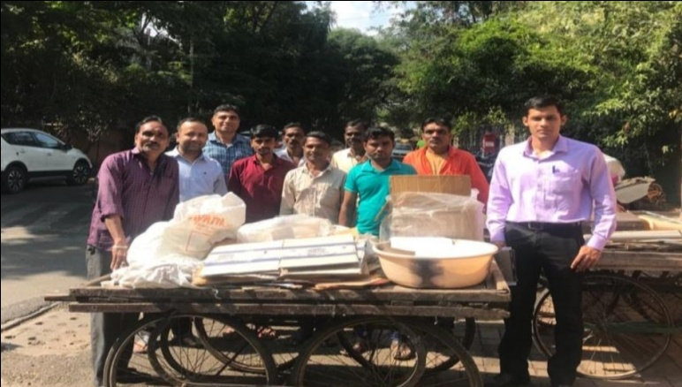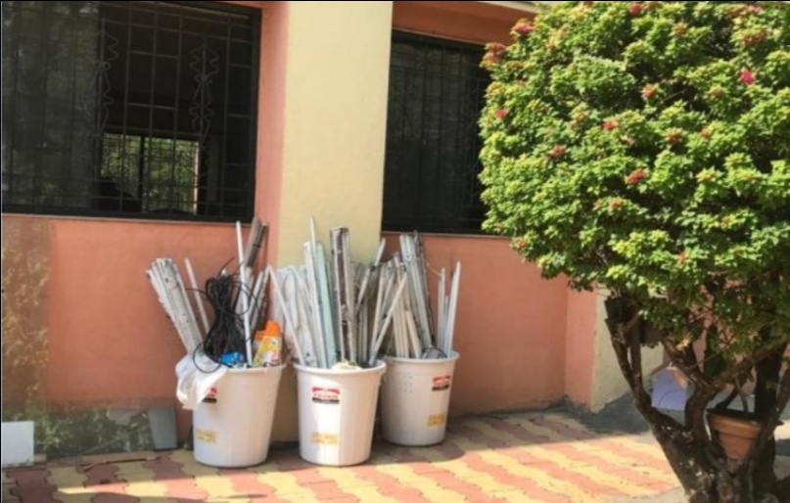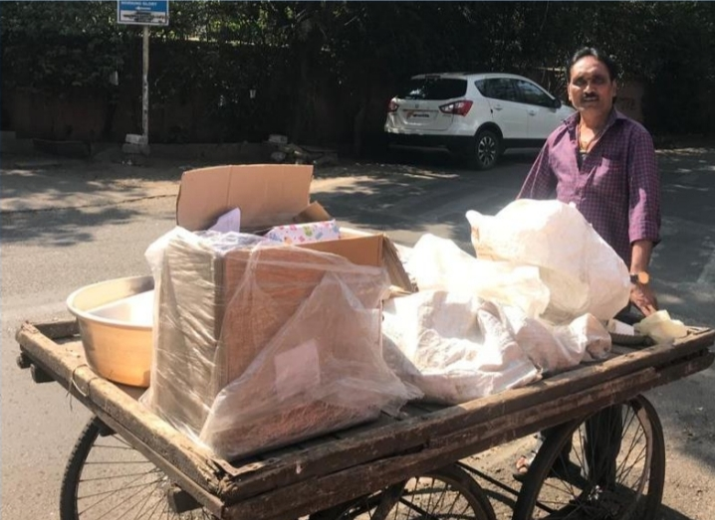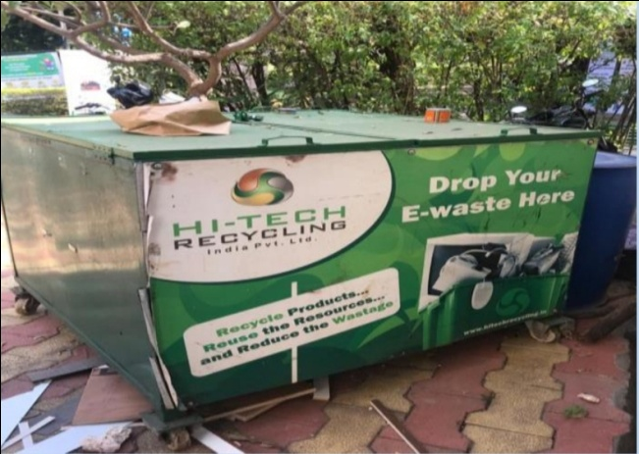

MAJOR NGOs AND PRIVATE ENTREPRENEURS INVOLVED IN E-WASTE MANAGEMENT IN PUNE CITY

The WISE project team interacted with major NGOs and private associations actively involved in e-waste collection and spreading awareness in Pune city. Major NGOs/private agencies and their initiatives are given below.

1. SWACH PUNE SEVA SAHAKARI SANSTHA LTD.

SWaCH is India's first wholly-owned cooperative of self-employed waste collectors and other urban poor. It is an autonomous enterprise that provides front-end waste management services to the citizens of Pune. E-waste is collected through donations, direct collection, and drop-off at centers as well as through awareness and collection drives. In 2012, the Maharashtra Pollution Control Board authorized SWaCH to collect and channelize e-waste as per the E-Waste (Management) Rules, 2012 (6). Through SWaCH, bulk generators such as schools, colleges, universities, companies, NGOs and other entities, send their e-waste for recycling to MPCB-authorized recycling centers. SWaCH has set up e-waste collection bins in private and government organizations, schools and colleges, and residential societies and commercial establishments. Citizens can also drop off their e-waste at the SWaCH office at designated centers or opt to have it collected directly from their homes. SWaCH collects old electronic/electrical items, furniture, bicycles, kitchen utensils, etc. They repair and reuse what they can and dismantle and recycle the rest. By organizing V-Collect events, SWaCH channelizes most of these items towards recycling and re-use, and away from the dumps. As Pune city’s first MPCBauthorized e-waste collection agency, SWaCH and its PRO partner ‘Karo Sambhav Pvt. Ltd.’ enable organizations to meet regulatory requirements for the safe disposal of IT e-waste, ensuring that it is 20 recycled responsibly (using the best available technology in India), and that it is handled, dismantled and recycled in an environmentally sound and socially responsible manner (6). These efforts are backed by the International Finance Corporation, as well as by industry giants like Dell, HP and Lenovo to help control India’s escalating e-waste problem. SWaCH, even after being backed by strong corporations, faces basic issues of storage and logistics in e-waste management. The NGO seeks more support from the government to make its model more sustainable in the long run.

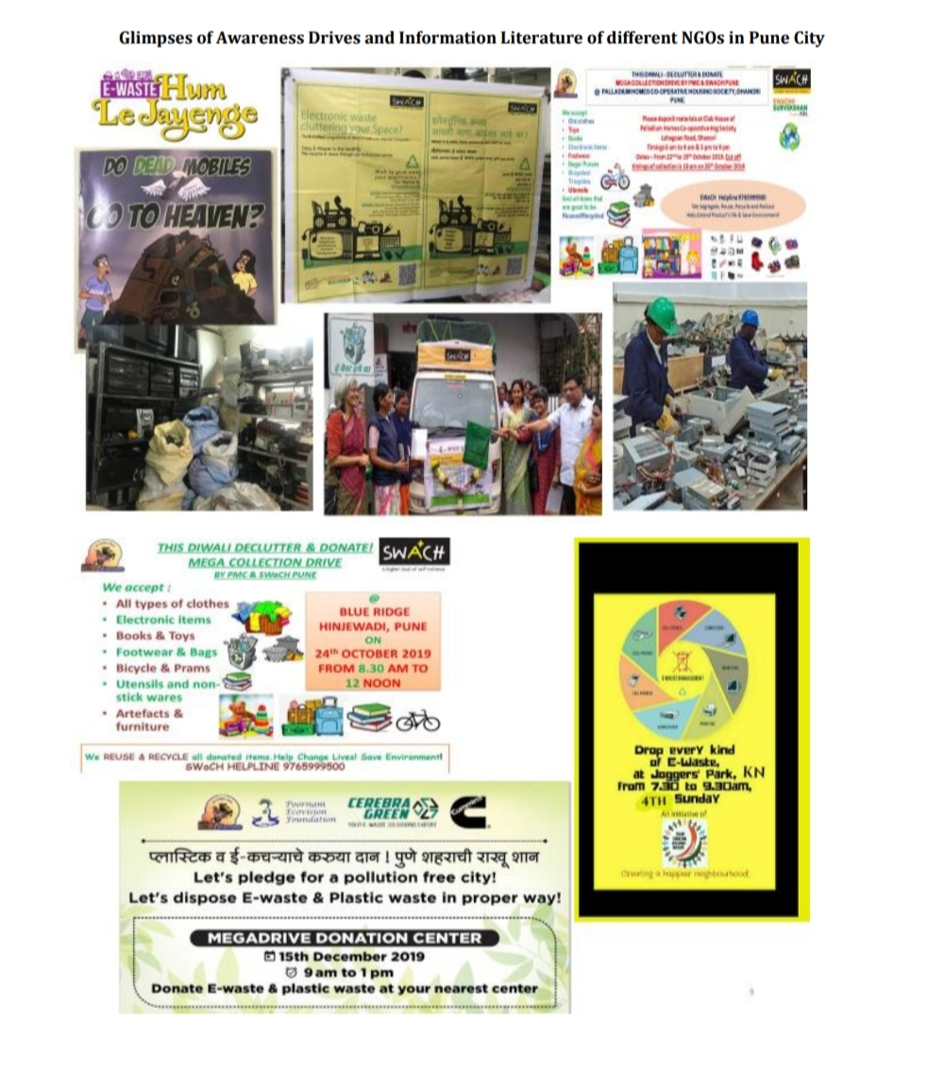

**2. POORNAM ECOVISION FOUNDATION**

PoornamEcovision Foundation is a social enterprise working for sustainable development since 2012. Poornam delivers solutions in fields like solid waste management, sustainable agricultural development, renewable energy management, and environmental management. Volunteer engagement is associated with all these verticals. Poornam is working extensively in collection of e-waste, plastic waste and toys from residential colonies and institutions in and around Pune. Reusable electronic goods are used for betterment of people being served in different organizations in the city. Remaining e-waste and plastic waste is channelized to authorized recyclers/ processors for safe disposal. Poornam has so far collected 67 tons of e-waste (7). The Foundation conducts various awareness initiatives such as e-waste management awareness initiatives for schools, colleges, societies and slums. These awareness sessions are supported by Cummins Foundation, Pune, a CSR initiative of Cummins India Ltd.

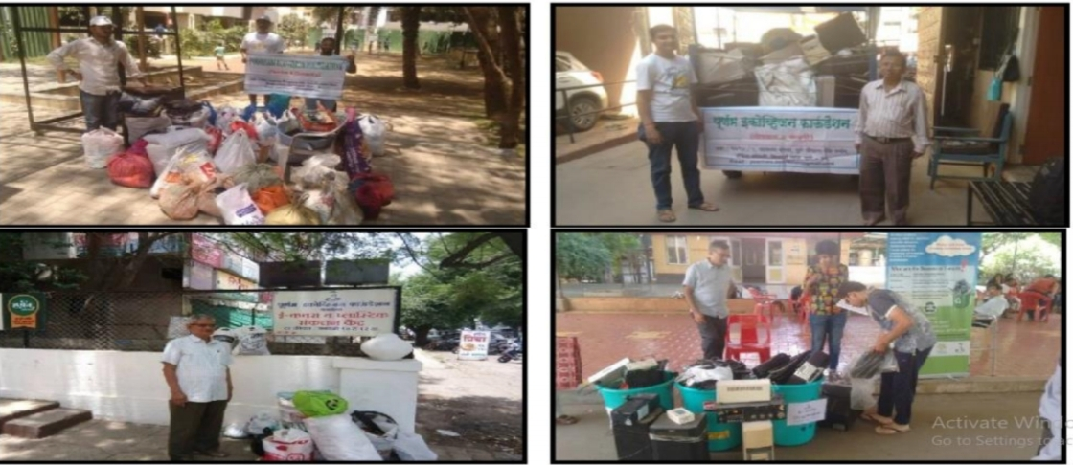

**3. JANWANI**

Janwani was established in the year 2006. Its Governing Board comprises philanthropists from Pune city with rich and diverse sectoral experience. Since its inception, 'Janwani' has kept its approach city-centered, collaborative, analytical and data driven. It has implemented various projects on the environment, governance, heritage, traffic and transportation and urban planning to make Pune the most livable city' in 21 the country. Janwani is implementing three major projects on solid waste management like e-waste collection, segregated garbage management in Pune city with its partners the Pune Municipal Corporation, Pune Cantonment Board, Adar Poonawalla Clean City Initiative, Cummins India Ltd. & Persistent Systems (8). In 2016-17, Janwani in partnership with the PMC, Swach Cooperative (waste-pickers organization) and Cummins India Ltd created a zero garbage ward model, located in the southern part of Pune. The role of Janwani as a facilitator was to create awareness about segregation and increase collection of garbage. Various programs helped convey the message effectively to various strata of society. The programs included rallies, puppet shows, street plays, cleanliness drives, film shows, and poster exhibitions, etc. Even after being an active player in Pune’s e-waste management for over a decade, Janwani is still battling for administrative support from regulatory authorities for logistics and storage facilities. They find it difficult to transport e-waste collected from different parts of the city to the storage facility (which is at their office) and then further connecting it with recyclers. It is only due to support from CSR initiatives, that theyare still able to continue their awareness and collection activities.

**4. CUMMINS INDIA FOUNDATION**

Cummins India Ltd, is a group of complementary business units that design, manufacture, distribute and service engines and related technologies, including fuel systems, air handling, filtration, emission solutions and electrical power generation systems. Cummins India Foundation was instituted in 1990 to channelize their commitment towards corporate social responsibility. All its initiatives, both in the local community and in other parts of India where Cummins operates, fall under the three key focus areas of higher education, energy and environment, and social justice and infrastructure. As part of its CSR activities, Cummins team and PMC are working with authorized recyclers for ensuring eco-friendly processing of e-waste. Cummins’ volunteers spread awareness regarding e-waste pollution and need for recycling in schools, housing societies and colleges in Pune city. Cummins’ recently inaugurated their own permanent center for e-waste in Kothrud area.

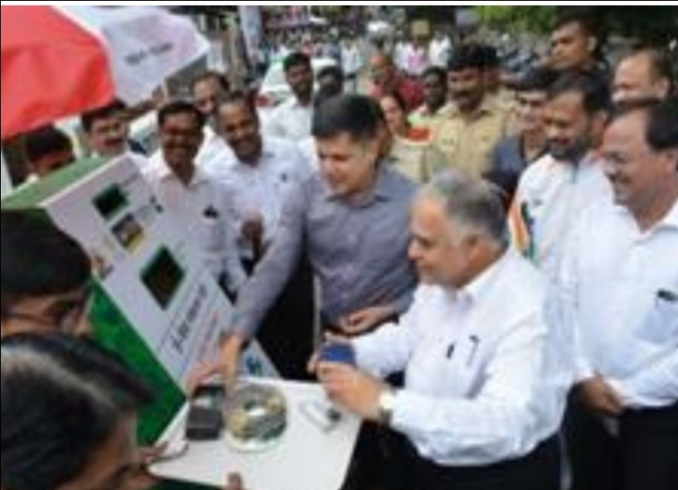

MAJOR FINDINGS, CONCLUSIONS AND RECOMMENDATION

The E waste market in Pune is not a separate market. It is a sub-market of the regular scrap Market. There is however some degree of specialization both in collection and trading where not all collectors and traders deal in E waste. E waste is among the scrap commodities collected by Bhangarferiwallas and traded by retail scrap traders to whom they sell the items. Both expressed their hesitation in collecting and storing e-waste because of the risk of being harassed by the police on account of the absence of proof and records of transactions from domestic and small generators. The bhangarferiwallas are hardly in a position to produce such receipts from the generator.Bhangarferiwallas, dabbabatliwalis and waste pickers have unmatched reach to every household and enterprise in the city. The costs of collection are usually the highest in any recycling activity and therefore a key determinant in the financial viability of recycling. Bhangarferiwallas are self employed and earn their livelihoods from collection, thereby subsidizing collection costs through their labour. They are street entrepreneurs. They ensure that any electrical or electronic item or even its part which can be repaired and reused will indeed be repaired and reused. They work with the bare minimum requirement of fossil fuels, electricity and motorization and work depends largely on their physical and intellectual endowment. Any future strategy for environmentally sound e-waste management needs to take into account their tremendous contribution and incorporate them in the changing scenario.E waste in Pune is collected, segregated, dismantled and shipped to Delhi, Mumbai and Bangalore for further processing. The processes that are carried out in Pune include collection, trading, breaking, removing, recovering, sorting, segregation, shredding, washing, packing, transporting. Actual extraction and recycling are not carried out in Pune. Metals do get recycled in foundries around Pune. All the processes are carried out in the informal economy of trading where interpersonal relationships and oral informal arrangements are the modes of transaction. Formal documentation of E waste deals does not exist and cash trading is the prevalent practice. The exceptions may be those registered dealers who are in the on line and off line tendering processes. The trading enterprises may have some kind of registration under the Shops and Establishments Act, which is quite poorly enforced. Many of the enterprises that deal with collection and dismantling of E-waste would be classified in the micro and small category and would therefore be excluded from the EWMHR. The regulatory framework for E waste appears to be premised upon the belief that environmental compliance will improve if formal enterprises undertake the management of E waste. It is assumed that they will use technologies that are state of the art and environmentally more acceptable and those that will enhance resource recovery as well. The E waste management and handling rules favor big business interests and have led to the spawning of Ewaste management companies. The fuzzy part in this schema is the relationship between the informal and the formal and the terms on which they would relate. More specifically, it is not clear if the formal would supplant or complement what the informal is doing today. The informal sector currently recycles 95 percent of E waste. It is done entrepreneurially and profitably without any government intervention. Informal enterprises have a competitive edge because of their ability to work with low establishment, infrastructure and labor costs. The 33 downside is that environmental norms and conditions of work and occupational health and safety issues of labour are compromised. The solution is therefore not to replace the informal with the formal but to enable the informal to progressively improve and meet the requirements. Thousands of urban poor work in this sector, in collection as well as in the scrap establishments and intermediate processing. Future work on e-waste must attempt to include the tremendous strengths of the informal sector in terms of extensive outreach, low costs and low carbon footprint along with the strengths of the formal sector in terms of technological knowledge, legality and brand image and ability to invest in research and capacity building. The responsibility of Manufacturers of products that generate E waste, to substitute non recyclable material; ensure safe collection, reprocessing and disposal must be legally mandatory. Take back programmers in India are hopelessly inadequate. Manufacturers are raking in profits while workers and entrepreneurs in the informal economy, subsidise the cleaning of the mess that their products have created. Making stringent rules for recycling enterprises while leaving manufacturers free of any responsibility is like locking the stable after the horse have bolted. Products that end up in the E waste stream are manufactured for the most part in the formal sector which is relatively easier to police and enforce good practices. The entry of Dilliwallas over the past four years has had a favorable impact on the price of Ewaste in therecycling market. There are an estimated 100 such agents working in Pune and are extremely difficult to trace because of their highly mobile working style and because they are commission agents who work without any overheads and without owning any space.

REFERENCES

1. Agarwal, R. (2011, May 9). Comment on Draft Amendment on Plastic Waste (Management and Handling) Rule 2011. Toxics Link .
2. Chikarmane, P., Deshpande, M., & Narayan, L. (2001). Report on Scrap Collectors, Scrap Traders and Recycling Enterprises in Pune. Pune: ILO.
3. Chikarmane.P, Narayanan.L. (2005). Garbage generation and collection in Pune city. Mumbai: All India Institute of Local Self Government.
4. Majumdar, A., Roy, S., Joshi, P., Kumar, V., Marda, V., & Chandra, R. (Year Unknown). E-Waste: The Indian Context. Kozhikode: IIM Kozhikode
5. MPCB. (2007). Report on Assessment of Electronic Wastes in Mumbai-Pune Area. Mumbai: Maharashtra Pollution Control
6. Toxics Link. (2011). Waste Electrical and Electronic Equipment. New Delhi: Toxics Link
7. <http://www.swachcoop.com>
8. Toxics Link. (Year Unknown). E-Waste in India: System Failure Imminent - Take Action Now. Retrieved May 23, 2011, from www.toxicslink.org:www.toxicslink.org/docs/06040_rep sumry.pdf
9. RICHARD HEEKS, LOGAKANTHI,SUBRAMANIAN& CARYS JONES (2013) Understanding eWasteManagement in DevelopingCountries: Building Sustainability in the Indian ICT Sector E-waste pune mirror report (2011).

10) Toxics Link. (Year Unknown). E-Waste in India: System Failure Imminent - Take Action Now. Retrieved May 23, 2011, from www.toxicslink.org:www.toxicslink.org/docs/06040_rep sumry.pdf